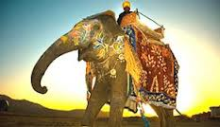
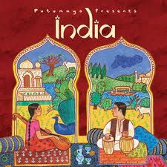
CALEDONIA GOLF CLUB
IN ASSOCIATION WITH
THE GANGES INDIAN RESTAURANT
CURRY BUFFET NIGHT


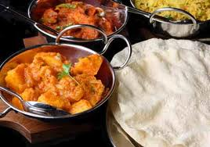
FRIDAY 21st MARCH 2014 AT 7.30 PM

TICKETS £15 PER PERSON
INCLUDES A SELECTION OF CURRIES AND ACCOMPANIMENTS

HOUSE WINE - £10 PER BOTTLE

BOOK NOW

